**LINUX + GITHUB+ JENKINS + DOCKER + DOCKERHUB + ANSIBLE**

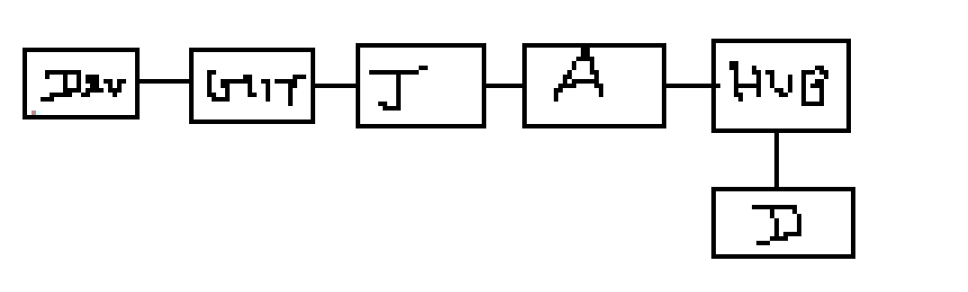

In SCM We will store Dockerfile which is responsible for tomcat image.

In git we will store playbook which will be responsible for creating the container on the remote machine.

**STEPS:**

1. As a developer we will create some webapp files and store these files onto git repo.

<https://github.com/devops-srv/docker-example>

1. As devops engineer we will create two files one is dockerfile and another one is playbook will be committed in git repo.
2. Jenkins /Ansible / Remote server.
3. We will install docker on both the machines Ansible master and remote servers.
4. We will add the user account to docker groups
5. SSH connection b/n jenkins and ansible server
6. Jenkins :-
7. Defile the ansible server details in Jenkins configure system.
8. Create a Maven job:-

Task1: Creating the docker image and push it into a docker hub.

Task2: Create the docker container on remote sever using the playbook.

1. Accessing the tomcat webapp from the Google chrome

**IN ASNIBLE:**

Yum install docker -y

Usermod –AG docker srv

Make password less authentication vi /etc/ssh/sshd_config

Cat /etc/group | grep docker

Mkdir /opt/test (Once we create a jenkins job all the files will comes to this directory)

Chown srv:srv test

Docker login in ansible

**IN REMOTE SERVER**(docker)

Yum install docker –y

Start and enable the docker

Usermod –aG docker abc

Cat /etc/group | grep docker

**IN JENKINS:**

Make password less authentication.

Vi /etc/ssh/sshd_config

Systemctl restart sshd

Ssh-keygen

Ssh-copy-id

**IN JENKINS DASHBOARD:**

Webapp/target/*.war

Webapp/target

//opt//test

*Cd /opt/test*

*Docker build –t jon .*

*Docker tag jon ponraj0204/jon*

*Docker push ponraj0204/jon*

*Docker rmi ponraj0204/jon*

*Cd /opt/test*

*Sudo ansible-playbook –I /etc/ansible/hosts continer.yml*